**/*Crack4Success Project Description*/**

**Registration:**

// every field required (no optional fields)

**1. Username:** characters (3 to 15)

**2 .Email:** Unique (cannot create two accounts for same mail id)

**3. Password:** characters (7 to 15)

**4. Confirm Password:** same as password

**5. Qualification:** B.Tech only

**6. Branch:** CSE only

**7. Course:** Only one course is selected (GATE or Job or GRE or CAT)

**Login:**

two fields are required

1. **Email id** (provided during registration)

2. **Password** (which is used in registration)

**Site side Panel:**

1. **Syllabus:** provides Syllabus(GATE or Job or GRE or CAT based on the user selected course) in text form or PDF format(downloadable)
2. **Notifications:** shows the dates of registration (GATE or Job or GRE or CAT based on the user selected course),hall tickets available date ,examination date and timings and any further updates
3. **Previous Question Papers:** previous question papers (GATE or Job or GRE or CAT based on the user selected course) in pdf link format (downloadable)
4. **Video Tutorials:** Video lecture links(GATE or Job or GRE or CAT based on the user selected course)
5. **Materials:** E-materials (GATE or Job or GRE or CAT based on the user selected course) in PDF format (downloadable)

**6. Mock Test:** Mock tests are only for GATE and Job.

**1. Gate:** (time 3 hours)

|  |  |  |  |  |  |  |
| --- | --- | --- | --- | --- | --- | --- |
| **Section** | **Question**  **No.** | | **No. of**  **Questions** | | **Marks Per**  **Question** | **Total**  **Marks** |
| General Aptitude | 1 to 5 | | 5 | | 1 | 5 |
|  |  |  |  |  |
| Technical  +  Engineering  Mathematics | 1 to 25 | | 25 | | 1 | 25 |
| 26 to 55 | | 30 | | 2 | 60 |
| Total Questions : 65 | | Total Marks : 100 | | Total Duration : 3 hours | | |
| Technical Section :   70 marks | | General Aptitude: 15 marks | | Engineering Mathematics :  15 marks | | |
| 25 marks to 40 marks will allotted to Numeric Answer Type Questions | | | | | | |

**Multiple Choice Questions (MCQs)**

These questions are objective in nature and each question will have choice of four answers, out of which the candidate has to mark the correct answer. Each question carries 1 or 2 marks questions in all the sections.

**Numerical Answer Questions**

There will be no choices available for these types of questions. A Numeric Answer question carries 1 or 2 marks questions in all sections. The answer for these questions is a real number to be entered by using mouse and virtual keypad displayed on the monitor. No negative marking for these questions.

|  |  |  |
| --- | --- | --- |
| **Negative Marking** | | |
| Questions Type | Marks | Negative Marking |
| Multiple Choice Questions (MCQs) | 1 mark | 0.33 |
| 2 marks | 0.66 |
| Numerical Answer Questions | 1 mark | Nil |
| 2 marks | Nil |

**2. Job**

Aptitude test: 25 questions each one carries 1 mark no negative marking (50 minutes)

**Menu Bar:**

1. **Home:** displays an image related to crack4success

2. **Performance:** displays the marks scored by them in mock test (displays average marks if more than two mock tests are written) in a table.

And displays the predicted rank with the obtained average marks in all mock tests

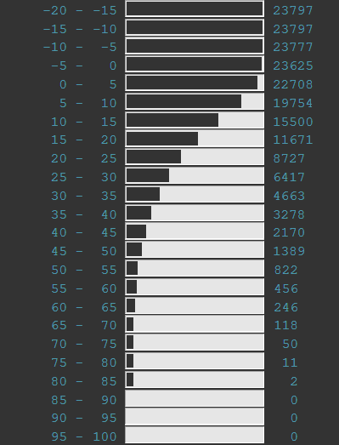

3. **About:** describes the purpose and features of the website and contact information of the admin for queries.

4. **Me:** display the user information in website and allows user to change his name, email, password which was given during registration.